BIMOBA
people name Mɔab, Bimoba (sing. Moa)
to some others Mɔba
language Mɔar
home area Mɔak, Mɔakuni, Mɔabting about 800 sq km
other local peoples (Mamprusi, Kusasi, Konkomba?)
main town Bunkpurugu
chief Nana ?? has his skin in Bunkpurugu
principal god Bogri
main occupation farming
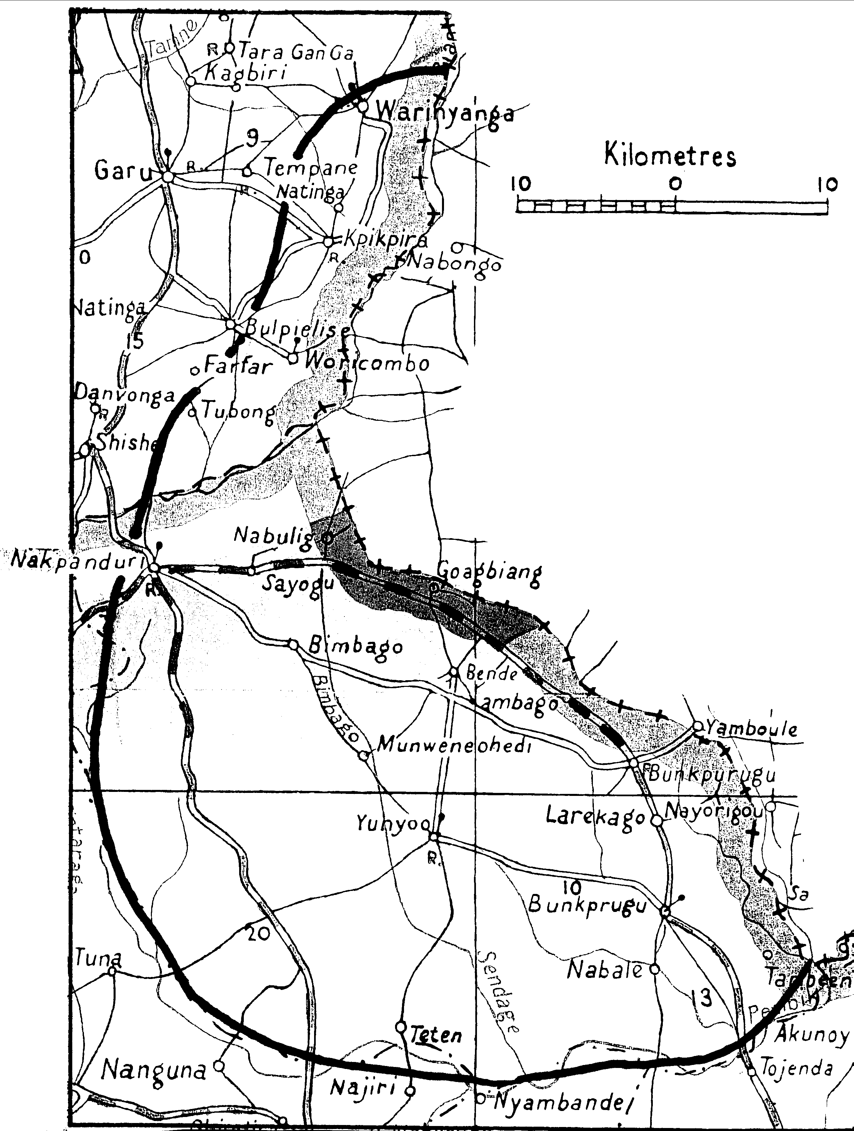
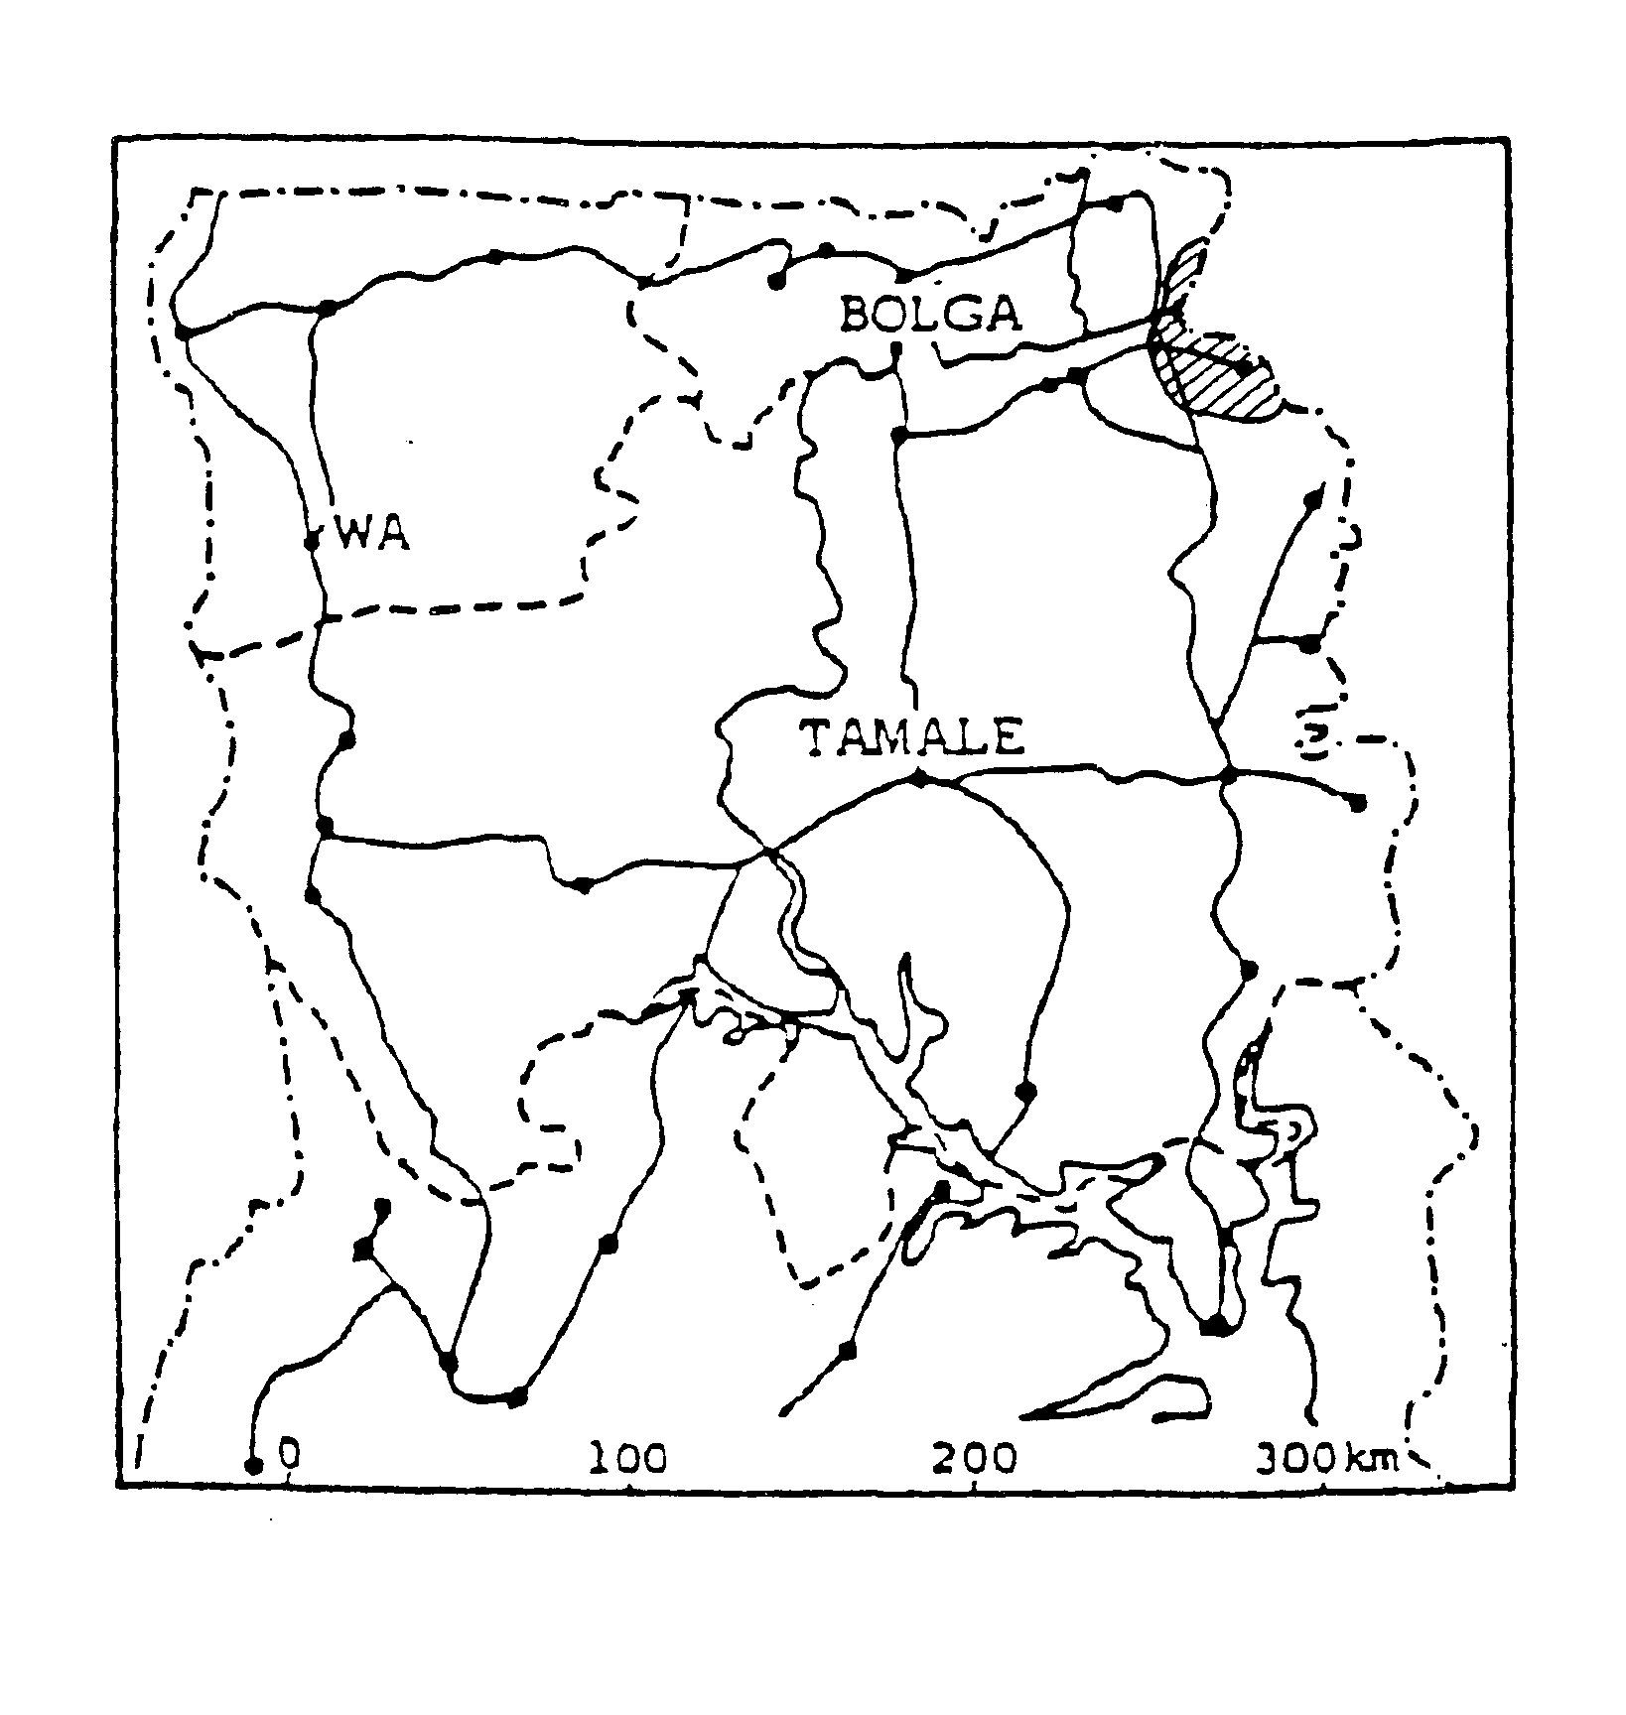
location Part in Upper East and part in Northern Region. The border with Togo dates from the Anglo-French Convention of 1898 which divided Bimoba in two; on the west side is a strip about 20 km wide from Warinyanga in the north to Tambiing in the south. This now covers parts of Tempane-Garu, Gambaga, and Bunkpurugu-Yunyoo Districts. The rest of the Mɔab people live in Togo, east of the border.
Jakper Naandam, lecturer in Animal Science at UDS,Tamale, discusses
PROS AND CONS OF BIMOBA SELF-ESTEEM
From Nakpanduri to Bunkpurugu, Bimoba have sought to settle in elevated lands, perhaps to spot enemies advancing from a distance, or for some other reason. This preference for elevated land appears to have become part of their social fibre, and to translate as self-esteem or self-respect.
Self-esteem is such a compelling force that scarcely would you find a family allowing a handicapped member (blind, crippled, mad etc.) to beg for alms – that is an unwritten abomination, cast in stone. Families are prepared to go an extra mile of confining and perhaps chaining mad relatives — not recognizing this as unkind and contrary to human rights — rather than allowing them to roam publicly and bring ridicule on the family. They would prefer to shoulder the burden of care.
This self-esteem is vividly implied in a popular Bimoba adage: Samɔ ki bant diboori sab, which translates “A stranger cannot recognize seed millet or TZ (tuo zaafi)”, meaning that a host would use the last bit of seed-grain in the barn to prepare a meal for a stranger, rather than allow him to go hungry. The stranger would not know that the meal is using up the last of his host’s seed grain. This kind of obligation is still very much alive even amongst the poorest families today.
There is a kayayee (portering) phenomenon among some ethnic groups in northern Ghana where young girls migrate from the villages to the cities to work as porters. However you would you never see a Bimoba girl being involved in kayayee. In the same way, Bimoba boys formerly preferred work in cocoa plantations to portering. They would never consider a job of pounding fufu in a restaurant, for example. Neither would they opt to be a paid conservancy labourer even in the most extreme circumstances. Bintuotuk or night-soil carrier was not an acceptable word among the Bimoba. Today Bmoba also do that job.
In all these cases, one may debate whether this self-esteem is an asset or a liability to Bimoba, because it has landed the Bimoba on hilly lands and high ground, sometimes with huge rock outcrops, whereas flat land abounded in the northern regions at the time they were searching for settlements. Notwithstanding, if these rocky lands could be exploited, the settlements in which the Bimoba find themselves would be a huge asset for generations to come.
POPULATION
Table 1 BIMOBA – COMPARED BY YEAR
 | 1960 Census | PLR 1984 estimate | 2000 Census | Ethnologue ’04 estimate | Josh P 2006 estimate
3 N Regions
7 S Regions
GHANA Total |  | 60,200 | 113,130 | 120,000 | 98,090
Table 2 BIMOBA – COMPARED BY REGION (2000 CENSUS) Table 7 (pp 18-23)
3 Northern regions
Upper East | Upper West | Northern | NORTH TOTAL
23,946 | 183 | 49,013 | 73,142
7 Southern regions
Western | Central | Greater Accra | Volta
4,303 | 675 | 2,100 | 836
Eastern | Ashanti | Brong Ahafo | SOUTH TOTAL
1,525 | 15,462 | 15,087 | 39,988
GHANA Total |  |  | 113,130
35% of Bimoba live outside Northern and Upper East Regions
LANGUAGE
Mɔar is a Gur language of the Oti-Volta (Gurma) sub-group, closely related to Konkomba and Bassari.
Two dialects, Dagbann and Benn, are spoken on both sides of the border, and each is subdivided according to the towns in Togo from which they originate. .
Language use Main trade languages are English and Mampruli. A little Mɔar is taught in schools. Mimɔba is used in church. Benn is spoken in Toojin, Panaatiik, Jiambari, Bembagu and many other villages around Bunkpurugu.
LITERACY/BIBLE TRANSLATION
GHANA |  |  |  |  | TOGO
GILLBT started work in Look | NT started | NT printed | OT started | Bible printed | SIL started work (which dialect?)
1964 | 1966 | 1986 | 1989 | 2004 | 1986
ORIGINS AND HISTORY
The Mɔba, according to Fuzzy, appear to have migrated south from Fada n’Gourma in what is now Burkina Faso towards the end of the 17th century, then to have been driven by the Mamprusi and Dagomba, using Chokosi mercenaries, to the country they now inhabit. They mingled with the Bem and groups of Mamprusi and Konkomba to form the Mɔab or Bimoba people. (NJ)
Another version, quoted by Max Assimeng (Bimoba Sociological Study, unpublished report for CUSO – Ghana 1990) is that three different clan groups, all deriving from the same stock – Bem, Mɔba, and Dagbaan – migrated southward from Nung in what is now Burkina Faso. (NJ) At the time they were effectively occupying their present homeland, and the British and Germans were extending their spheres of influence. The Bimoba were in the "neutral zone" established by the colonial powers in 1888; the Anglo-German convention of 1899 finally drew the international border to the west of their territory, placing the Mɔab under German rule. However after World War I Britain and France divided former German Togo between them, and established the present border which divides Mɔakuni between Ghana and Togo.
Kpeebi suggests another theory: that when the Mɔab were split into French and British territories those in the British territory were called British Mɔba or “B” Mɔba, hence the form of the word Bimoba in Ghana. This version seems to have some plausibility because in Togo where Bem are in the majority they are still known as Mɔba whereas only in Ghana are they called Bimoba.
The colonial occupation brought to an end the fighting between the Bimoba and the Chokosi or Anufo.
AUTHORITY
The Bimoba paramount chief has his skin at Bunkpurugu. However he is appointed by the paramount chief of the Mamprusi who is based at Nalerigu Up to the 1960s each village had to send labourers to work on the Mamprusi paramount chief's farm at Nalerigu once a year, but this is no longer done.
There is a chief, usually a man, in every village, appointed by the divisional chief or paramount chief as the case may be. When the skin becomes vacant it is contested by interested royals, but the divisional or paramount chief has the prerogative of choosing and appointing from among the contestants. (NJ)
The levels of chiefs, in ascending order, are: village headman (kabonnab), village chief, divisional chief, paramount chief. Each lower chief is subject to his superior, but the superior does not have absolute control over the land of the other; suzerainty is not practical in Mɔabting. Chiefs have to be consulted if one wants to make a farm, but they are merely custodians, and do not own the land – ownership is vested in family heads. There are good inter-tribal relationships. Tribute was formerly seen as a bond for good relationships and loyalty, but has become a thing of the past. (NJ)
The chief is assisted by a council of elders, who sit on judicial cases. (KF)
MIGRATION
People migrate in search of better farming land, to avoid sickness or hunger, to exercise more control over an unwilling wife; a son may migrate with his family to secure rights over farm produce (at home, produce belongs to the head of the house). Bimoba settlements in the south include Boom near Kintampo and Kwasu near Bechem in Brong Ahafo; Tepa and Nkaase in Ashanti and Enchi in Western Region.
Migrant communities choose a chief from among themselves, and tend to continue their traditional religious practices. People return home periodically for funerals.
The Lutherans have made some attempt to trace migrant Bimboba farmers in Brong-Ahafo; their strategy is to work with household heads with a view to bringing in the whole household. They have a Bimoba Lutheran church at Kwasu near Bechem, with 3 elders, 5 men in the leadership class, and some 10 household heads in the congregation. They find a Bimboba church has a great appeal to these migrant farmers, and it seems that a high proportion of the Bimoba community belongs.
INHERITANCE AND MARRIAGE OF WIDOWS
Inheritance is patrilineal [for both men and women?]. A man's children inherit most of his property, though his brother takes some things including his bow. If the children are young, the brother is responsible for them; if they inherit livestock from their father, the brother will care for the animals until the children are old enough.
A woman's brothers and patrilineal family inherit all her possessions. If her husband owes her anything he must settle the debt on the day she dies.
Widows traditionally marry a brother of the deceased, or a relative of her husband living in another compound and go to live with that person after the funeral. In recent times, a widow with more than two children may continue to live in her late husband’s house for the children's sake, while still being free to marry the relative. Nowdays fear of HIV/AIDS limits readiness to enter into new relationships.
THE COMPOUND
Compounds are built about 50 metres apart. A compound requires a minimum of five rooms and more if there are fowls and animals; the average would be about 12-15 rooms. The occupants may be a) a man and his wife/wives and children; or b) two or more brothers and their wives and children; or c) a man and his son or sons, and their respective wives and children. Nowadays, for privacy, every male adolescent builds his own room, with help from his parents.
The main entrance faces west. Outside is a thatched shelter used for resting; inside there is a customary order of rooms, anticlockwise starting from the right to left. To the right of the entrance is the naakuk, which contains the patir and other fetishes, and for traditional purposes - when the landlord dies he is laid in state there; daughters are given in marriage to their in-laws in that room. The next room to the right is the landlord’s room, then rooms for the first wife and other wives; rooms for children; and last, before the left of the entrance, a room for animals and poultry. Animals and poultry may also be kept in the naakuk [please check this].
When a household grows beyond 12 or so rooms a man may start a new compound.
Formerly most rooms were round and thatched in the distinctive Bimoba style, which has separate stalks of grass projecting from the eaves in a fringe. Rectangular rooms roofed with zinc and aluminium sheets are getting more popular especially with younger people.
A TRADITIONAL BIMOBA COMPOUND
This plan shows a traditional compound of mostly round rooms, including an indoor kitchen and outdoor hearth; nowadays the indoor kitchen is giving place to open-air kitchens sheltered only by a roof.
TRADITIONAL BIMOBA COMPOUND
1 | owner’s room | 12 | deceased grandmother’s patir
2 | senior wife’s room | 13 | granary
3 | 2nd wife’s room | 14 | walled kitchen (2 doors for 2 wives)
4 | young men’s room | 15 | young men’s bathing areas
5 | male visitors’ room | 16
6 | store-room, granary | 17 | wives’ bathing areas
7 | cattle-byre and gods | K1 | kitchen
8 | poultry (can be used for granary) | K2,3 | K3 open-air kitchens
9 | goats | B1 | young men’s bath room
10 | naakuk (for patir or family gods) | B2 | wives’ bathing areas (used by husband)
11 | poultry (hole in wall to admit them)

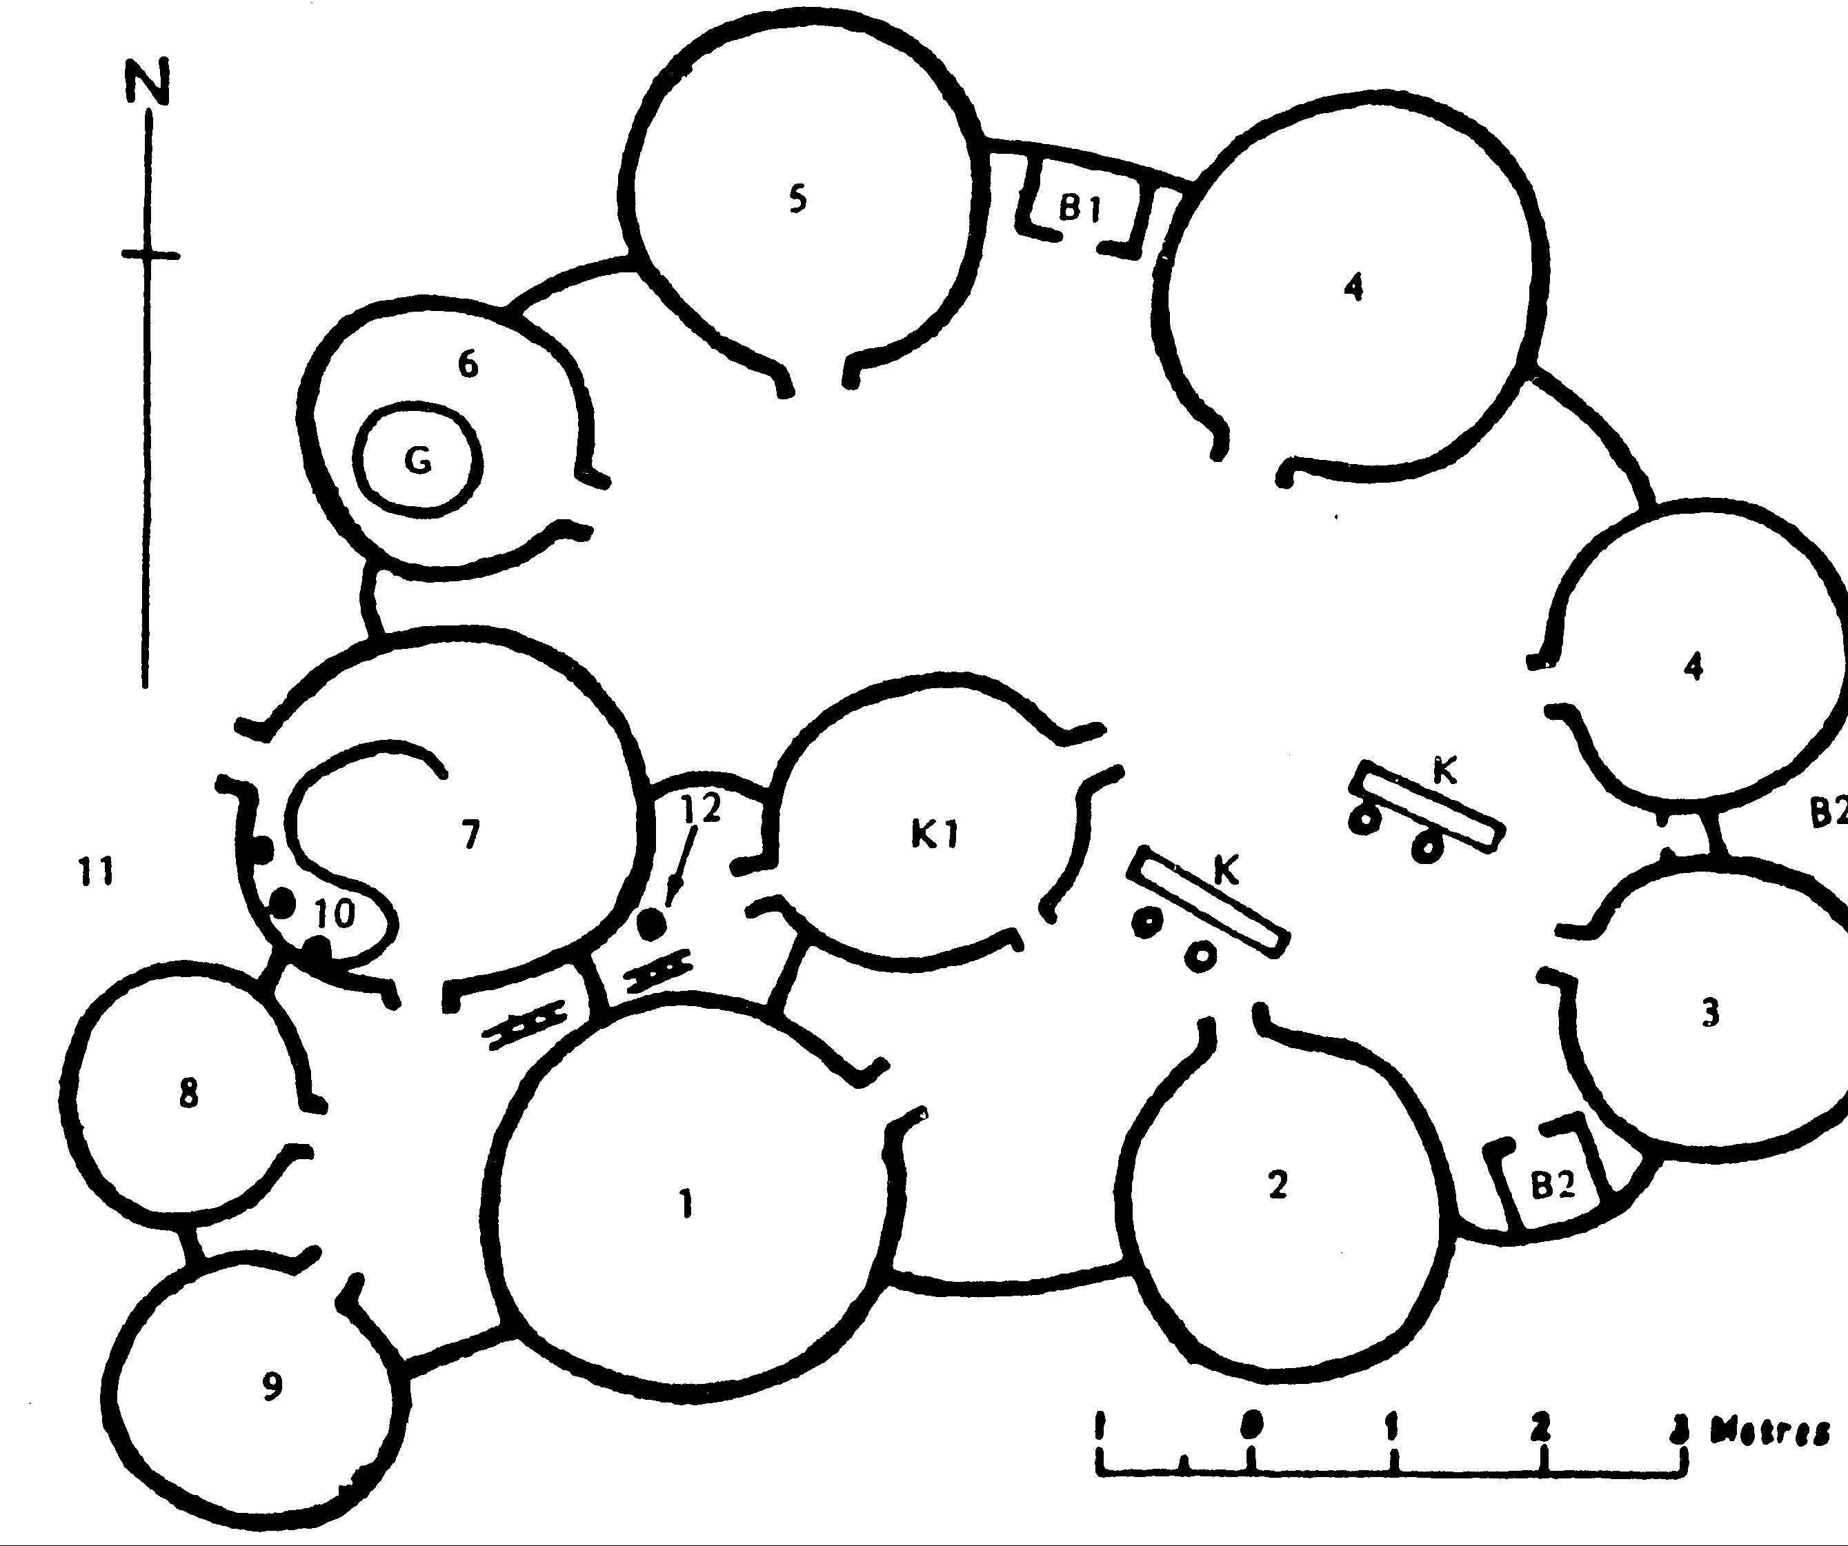

FARMING etc
A man does not take up a farm of his own till he marries then he may acquire a plot belonging to his family, with the agreement of the headman and the village chief . In the past, sale of land was unknown. The farmer used to pay a yearly rent of one bundle of guinea-corn, whatever the size of the farm, but this payment fell out of custom in the ?1970s? (KF)
The main farms are in the bush, up to 5 km from the village, and crops include millet, guinea corn, groundnuts, beans (bambara, black-eyed), okra, pepper, and occasionally yams and sweet potatoes. There are also small farms around the compounds where early millet, maize, and okra are grown. Since population density is not great, land is never under cultivation for more than four years. When left fallow it continues to belong to the first people to farm there.
Women and children collect bush products like dawadawa and sheanuts from April to June, partly for local consumption, partly to sell for cash. The baobab can produce a maximum of 30-50 basketfuls of fruits and 8 to 10 basketfuls of leaves [what are these used for?]. (KF) Other fruits include:
sinsabuk | (lannea microcarpa) a small green/wine-coloured fruit
naakpakera | a brown-coloured fruit
naasabara | yellow, diameter about 2 cm
naana | (vitex) black
biila | dark red and very acid
kpinkparuk | (borassus) is an orange-yellow fruit about as big as a medium-sized pawpaw, which has a very large seed and grows on a tall palm tree. The root can be dug up while the tree is quite small, and eaten like a yam.
Livestock &c Sheep, goats, and poultry are reared. Pigs are reared mainly by women for social functions including marriages, funerals, and initiation ceremonies. Cows were formerly used mainly for sacrifice to the patir fetish, and as an investment. Now bullocks are used for ploughing and to sell for cash, for instance to buy roofing sheets.
Hunting The larger animals are no longer found, but during the dry season the bush is burnt and the people hunt wild guinea fowl, rabbits, and in some areas antelope and grass cutters [still?]. Game is consumed by the family, sold in the market, or dried and smoked for consumption or sale later.
Crafts include making baskets, mats, ropes, fans (from palm leaves), and hats, both for home consumption and to raise cash. In Togo the Mɔab make pottery; in Ghana the Kusasi are the potters.
TRADE AND DAILY LIFE
Markets are held every third day. The main markets are at Bunkpurugu, Nakpanduri, Bimbagu, Jimbale, Nabong No 1, and Gbingban [on what days?]. Traders come to these markets from outside the area to sell tomatoes, onions, salt, rice, kola nuts, and yams; they buy grain and groundnuts; beans, peppers, and okra; sheanuts dawadawa pods, sheep, and chickens. People sometimes go to Nalerigu market to get a better price for their millet.
In recent years more markets have started for purely local trade, including sale of beer, pork, and peppers. [spelling?]
Water and fuel 20 years ago women used to have to carry water on their heads up to 5 km, in large enamel basins; occasionally barrels of water were drawn in small donkey-carts. Over that period Government, foreign government schemes, and NGOs have drilled many more wells and boreholes, drastically reducing the distances involved.
Nowadays it is the search for fuel that causes women to walk long distances, because of the degradation of natural forests. Those who can afford it carry their fuel on donkey-carts. Grain stalks are used when available.
A wife cooks for her husband and children, but especially where there are young men in the compound all may eat together. The main meal is TZ (saab).
EDUCATION AND HEALTH
Education There are primary schools in all towns and larger villages throughout the area, and children hardly have to walk as much as 5 km to school. There are a total of [number] JSS at Bunkpurugu, Bimbagu, Nakpanduri, Kambaauk, and [number] other centres, each one fed by 3-4 primary schools.
Health There is an Baptist hospital at Nalerigu, and a AoG general and maternity clinic at Nakpanduri. Government clinics have been established in Bunkpurugu, Nakpanduri, Kanbagu, and Jimbale; and a Roman Catholic health centre was opened at Binde in 200? There are traditional birth attendants in most villages, and some medical field workers.
[Which of the following are relevant to Mɔab – health posts at Gbintri, Gbingbamdi?]
SERVICES
Bunkpurugu/Yunyoo District was created in 2004, so the District Assembly can send its concerns to Government through the Coordination Council.
Electricity The Akosombo grid came to Nakpanduri first and later to Bunkpurugu, which had previously been served by a solar network run by an NGO.
There are police stations and post offices [?] at Bunkpurugu, Binde, and Nakpanduri.
Passenger lorry services In the 1990s the only daily route was
Bunkpurugu to Nalerigu; there were lorries to Bawku market, and weekly services to Techiman and Kumasi. Since then services have greatly expanded:
to Nakpanduri – Bawku | every 3 days (for Bawku market)
to Nakpanduri – Nalerigu | daily
to Tamale – Techiman – Kumasi | daily
to Tamale – Techiman | daily
to Gbingbani – Wanchiki [spelling?] | every 3 days (for market)
Jimbale – Gushiegu | every 6 days (for market)
Nasuan – Gbintiri | every 6 days (for market)
Yembouri (Togo) – Bankosi (Togo) | weekly
Bicycles and motorbikes have become much more common in the past 20 years.
RELIGION
Traditional Religion
Yennu, is the name for the supreme God and creator, and the Mɔab believe that whatever Yennu does, no one can undo it, but no sacrifices are made to him*. It is believed that if you do wrong he will judge and punish you after death.
The same word yennu is used in two other ways:
Many people hold that “Yennu” is also a minor deity, the god of birth, to whom women make intercession for a child. A formula believed to be infallible is to lay a calabash of water, or a decoction of herbs, on his shrine. The woman returns and drinks it next day, after which she must remain at home and speak to no one but her husband for six days. (KF)
During any sacrifice where lesser gods are named, the priest or elder first mentions Yennu = God, through whom the lesser gods derive their powers. (In this chapter we use Yennu with a capital letter to indicate both God and the name of the minor deity, though they have no connection.)
Thirdly, yennu means sun, day, and personal god. Sacrifices of goats, fowls, and sheep are made to him.
The god Bogri has power to cure disease, and many sacrifices are made to him. He protects and avenges all his people. It is believed that disease is caused by the anger of the gods, or by witchcraft, and an epidemic is attributed to the gods. Therefore, when an epidemic breaks out, fires are burnt and ceremonial dances performed on the paths to unaffected villages, that the evil may be halted. Patients are isolated, and all drumming, drinking, and fighting are forbidden. The same applies to a threatened attack in war. (KF)
Ancestors Each village has its own grove, which consists of a ring of shady trees, which may be surrounded by a dry-built wall of stone encircling an upright stone in the centre. The heads of enemies are deposited here, and all village ceremonies are held here. The ancestors are believed to avert harm from the community, and people bring pots of beer to the shrines. (KF)
All Bimoba clans have their earth-shrines, tingbaan, for instance Jabiir and Baajar, both located in Togo; such shrines may be a pile of stones or a tree, situated anywhere. Annual ceremonies are characterised by sacrifice of animals and fowls, feasts, and merry-making. Clan members in the diaspora may come home during these ceremonies to reinforce their unity as a clan.
There are also shrines of family gods, patir, mud effigies usually in human form, kept in the naakuuk.
The patir shrine is served by the family’s jamatoo., that is, the oldest person in terms of generation. Most families have their own jamatoo, though the Look people have only one for the whole clan. When jamatoo dies he is succeeded by the next oldest in his generation.
Jamatoo sacrifices at his patir shrine to purify those who have committed any offence, for instance adultery. He also performs a rite when any bush animal is killed, to protect the hunter; if this is not done the spirit of the dead animal may catch him and he may die.
If a sacrificed fowl falls with head and trunk facing the sun, that shows that it has been accepted. The jamatoo then puts some of the blood on the head of the patir and places the liver on top.
Personal gods are made of mud. An unmarried man's yennu is placed on the ground or on the wall of the naakuuk, a woman's in her bathing area. When the man marries his yennu is moved to the court yard as a result, when one is married and wants to tell people that he is married he says I have now entered the room or the court yard.
If a woman runs away from her husband she takes her yennu with her; it is a sign that she wants to make a final break.
Yennu, sometimes called paaba, may be images of people, stones (chicheri) or earthen pots, all of which are invoked in the name of their owner. People worship and make prayers for immediate wants to inanimate objects, such as trees, stones, or an axe tied to a tree. (KF) [personal god yennu and the personal paaba].
In almost all Bimoba communities there are tungbandam (diviners or fortune-tellers) who own tungbana, and profess to identify people, especially women, who practise witchcraft. The jaaba (soothsayer) tells people why they are sick, what sacrifice is required, and to which ancestor or fetish it should be offered. If the sacrifice is required by someone's personal god or patir, he may offer the sacrifice himself. The ninyuan can find spirits and invisible things, and thus can find witches. [is he a specialist witch-finder? how does he differ from jaaba?]
Sacrifices are offered to ancestors, for instance when offering them herbs to treat an ailment inherited from an earlier generation, or during the sacrifice to patir. Ancestors are invoked to stand behind an individual, family, or clan for success in some endeavour. In the process the ancestors’ names are always mentioned. (NJ)
Christianity (from PLR 1986)
Christianity was first introduced into Mɔabting from 1949 onwards by Pastors Shirer, Lehmann, and McCorkle of AG. About 1952 the AG established a general and maternity clinic at Nakpanduri, staffed originally by missionaries, now by Ghanaians. The late paramount chief supported Christianity and professed to be a Christian; he regularly attended Bunkpurugu AoG Church.
In the Catholic parish, in 1986, there was a "prayer leader" in every congregation; there were seven zones, and the parish priest [from Bunkpurugu?] visited every zone once in seven weeks, in addition to a monthly meeting which all [congregational leaders?] awee supposed to attend. They used a liturgy and New Testament portions (the four gospels and Acts) in a version translated by the Catholics in Togo, also a course book Dinne Kristoyab (The Christian today).
The Lutherans trained congregation leaders through regular classes in Bunkpurugus.
Conversion case history One man became a Christian partly though the witness of schoolboy relatives who received Christian teaching in school, and partly through evangelistic meetings held by missionaries in his village. This man became a pastor – but he says most people who became Christians at school have now drifted away from the faith.
Attitudes Christians and Muslims look on one another as pagans. Muslims regard Christianity as "the white man's thing"; Christians feel it is useless to witness to a Muslim as it only leads to argument.
Islam
There have been Muslims in Mɔakuni since the 1920s; their influence is small but some mosques were built during the 1990s. The mosques at Bunkpurugu and Nakpanduri were attended in the 1980s primarily by traders from outside the area. (NJ) Most Mɔar Muslims are illiterate. [in what ways has Muslim influence grown in the chief’s court in the past ten years? Please gather fuller information on Islam]
Some object to Islam on the ground that Muslims make people mad by the use of medicine. Traditional believers object to Christianity because it means giving up traditional religion.
The 1984 census listed 98 towns and villages, the 2000 census listed [how many?] In 2008 these places had the following churches:

Congregations by villages (compiled by Isaac Naantan Lambon, 2008)
See Introductory Notes (Abbreviations) for full church names

 | AME | Ap | AOG | AR | B | Cath | COC | COG | CON | COP | DL | ECG | ELC | EP | Mth | NAC | Pres | SDA | SYS | UCC | TOT
Bunkpurugu | 1 | 1 | 1 |  |  | 1 |  | 1 |  | 2 | 1 | 1 |  |  |  |  | 1 | 1 |  |  | 11
Pagnatik |  |  | 1 |  |  | 1 | 1 |  |  | 1 |  |  |  |  |  |  |  |  |  |  | 4
Kinkangu |  |  |  |  |  | 1 |  | 1 |  | 1 |  |  |  | 1 |  |  |  |  |  |  | 4
Gbankurugu |  | 1 |  |  |  | 1 |  |  |  | 1 | 1 |  |  |  |  |  |  |  |  | 1 | 5
Tambiing |  |  |  |  |  | 2 |  |  |  |  |  |  |  |  |  |  |  |  |  |  | 2
Bunbuna |  | 1 |  |  | 1 | 1 |  |  |  |  |  |  | 1 |  |  | 2 |  |  |  |  | 6
Jimbale |  |  | 1 |  |  | 1 |  |  |  | 1 |  |  |  |  |  | 1 |  |  |  |  | 4
Yunyoo |  |  | 1 |  |  | 1 |  |  |  |  |  |  |  |  |  | 1 |  |  |  |  | 3
Jiilig |  | 1 | 1 |  |  | 2 |  |  |  | 1 |  |  | 1 |  |  |  |  |  |  |  | 6
Nanyiar |  | 1 |  |  |  | 2 |  |  |  |  |  |  |  |  |  |  |  |  |  |  | 3
Kambagu |  |  | 1 |  |  |  |  |  |  | 1 |  |  | 1 |  |  |  |  |  | 1 |  | 4
Najoung 1 |  |  | 1 |  |  | 1 |  | 1 |  |  |  |  | 1 | 1 |  |  |  |  |  |  | 5
Najoung 2 |  |  | 1 |  |  | 1 |  | 1 |  | 1 |  |  | 1 | 1 |  |  |  |  |  |  | 6
Bendi |  |  |  |  |  | 4 |  |  |  |  |  |  | 2 |  |  |  |  | 1 |  |  | 7
Bimbagu |  |  | 4 |  |  | 1 |  |  |  | 4 |  |  |  |  |  |  | 1 |  |  |  | 10
Gbankondi |  |  | 1 |  |  | 1 |  | 1 |  | 1 |  |  | 1 |  |  |  |  |  |  |  | 5
Gbadauk |  |  | 1 |  |  |  |  | 1 |  |  |  |  |  |  |  |  |  |  |  |  | 2
Kambatiak |  |  | 1 |  |  | 2 |  | 1 |  |  |  |  |  |  |  | 2 |  |  |  |  | 6
Kauk-Jagoog |  |  | 1 |  | 1 |  |  |  |  | 1 |  |  | 1 |  |  |  |  |  |  |  | 4
Toojing |  |  | 1 |  | 1 |  | 1 |  |  |  |  |  |  |  |  |  |  |  |  |  | 3
Nakpanduri | 1 | 1 | 3 |  | 1 | 1 |  | 1 | 1 | 3 |  |  |  | 1 |  | 1 | 1 |  |  |  | 15
Duklotuk area |  |  |  |  |  |  |  |  |  | 9 |  |  |  |  |  |  |  |  |  |  | 9
Kambatiak/ Najoung/ area Bunbuna/ |  |  | 1 |  |  |  |  |  |  | 11 |  |  |  |  |  |  |  |  | 1 |  | 13
TOTALS | 2 | 6 | 21 |  | 4 | 24 | 2 | 8 | 1 | 38 | 2 | 1 | 9 | 4 |  | 7 | 3 | 2 | 2 | 1 | 137
[can the above table be adapted and completed?]

Total churches in this area
GEC survey  1985 | GILLBT survey  1989 | GILLBT SIU  2004 | GILLBT SIU  2006 | Lambon  2008
55 | 70 | 147 | 155 | 137

SOURCES AND RELEVANT LITERATURE [please add to these lists]
PUBLISHED BOOKS AND PAPERS CONSULTED
Kombat N Fuzzy
Kont: initiation rites of the Bimobas of Northern Ghana, unpublished thesis, c1979
Fragments of Bimoba history, student essay at School of Performing Arts, Legon, 1981
Konlan Kpeebi A sociological study of marriage among the Bimoba people [date and whether published please]
CONTRIBUTORS
Kombat Fuzzy, Nelson Jatuat, and Jakper Naandam are noted in the text where necessary by giving their initials thus: (KF) (NJ) (JN)
David Gbaruk and Mary Steele Notes and questionnaire answers, GEC 1985
Nelson Jatuat questionnaire answers, GILLBT 2006
OTHER RELEVANT LITERATURE
Pierre-Marie Carros Proverbes Moba Mission Catholique, Korbongou, Dapango, Togo, Vols 1 and 2, 1974
Ellison The Bimoba tribe, unpublished essay, 1935

